- DHCP Configuration Theory

Q1. In Cisco Packet Tracer, set up a simple network with one DHCP server and two client PCs. Configure the DHCP server to assign IP addresses automatically, then verify on each PC that it receives a different IP address from the DHCP pool?

Answer:
I created a simple network in Cisco Packet Tracer using one DHCP server, one switch, and two client PCs. The DHCP server automatically assigned a different IP address to each PC.
- Steps Performed:
1. Opened Cisco Packet Tracer and added one Server, one Switch, and two PCs.
2. Connected the Server and both PCs to the switch using Copper Straight-Through cables.
3. Configured the DHCP server with static IP 192.168.1.2 and opened Services > DHCP.
4. Created a DHCP pool named Serverpool with default gateway 192.168.1.1, subnet mask 255.255.255.0, and start IP 192.168.1.3.
5. Turned the DHCP service ON.
6. On PC0 and PC1, opened Desktop > IP Configuration and selected DHCP.
7. Verified that both PCs received different IP addresses automatically.
- Verification:
Device | Assigned IP Address | Subnet Mask | Default Gateway
- PC0 | 192.168.1.3 | 255.255.255.0 | 192.168.1.1
- PC1 | 192.168.1.4 | 255.255.255.0 | 192.168.1.1

- Result:
The DHCP server worked successfully. PC0 received 192.168.1.3 and PC1 received 192.168.1.4, so both clients received different addresses from the DHCP pool.
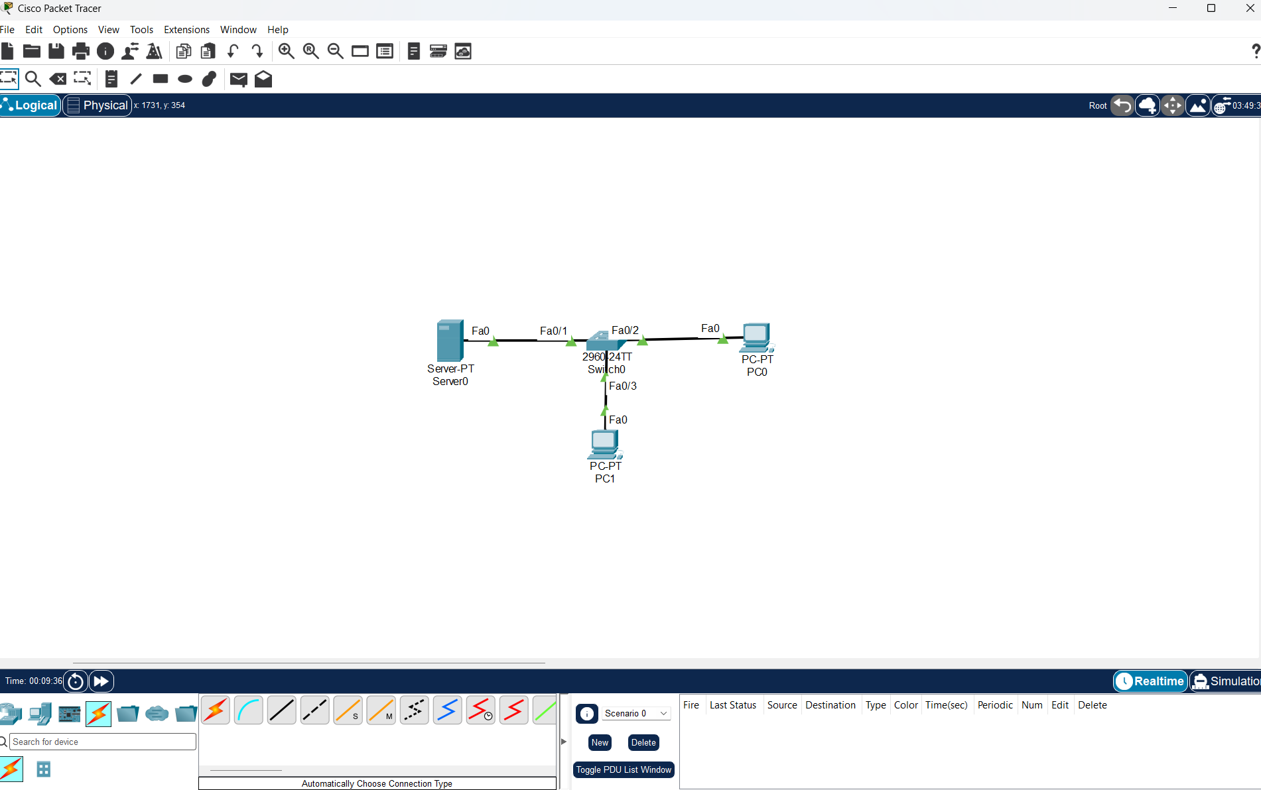
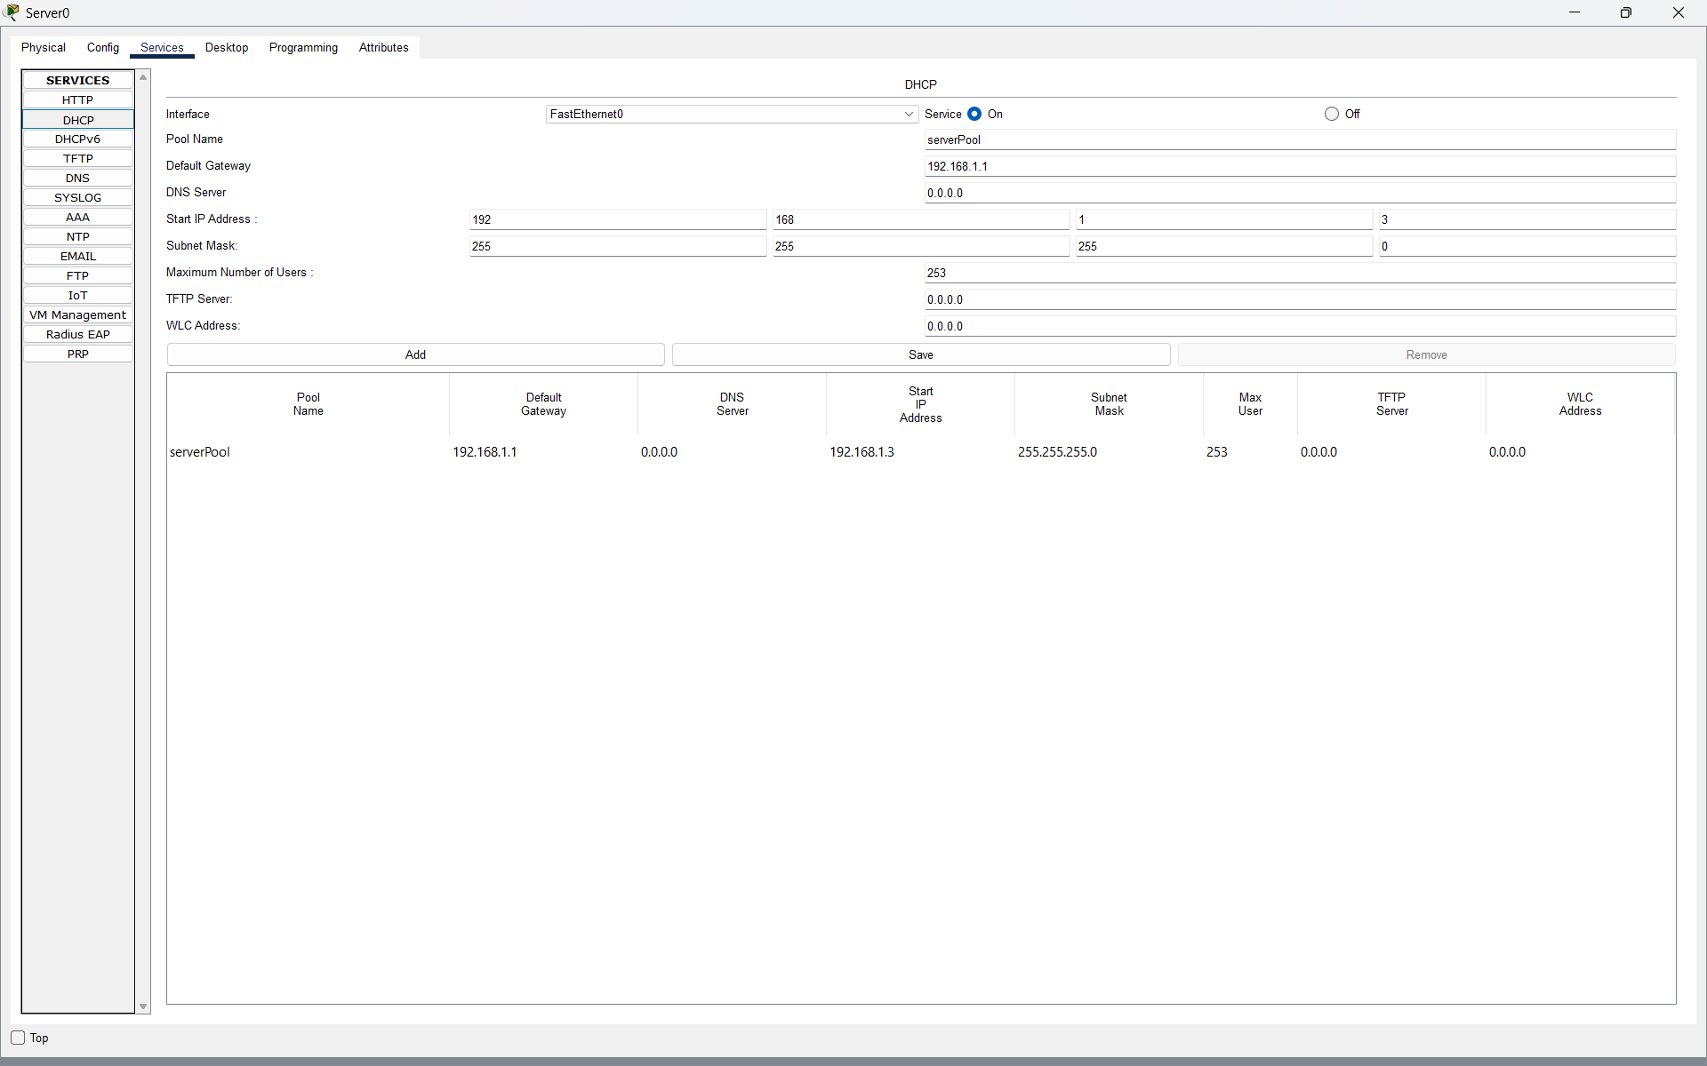

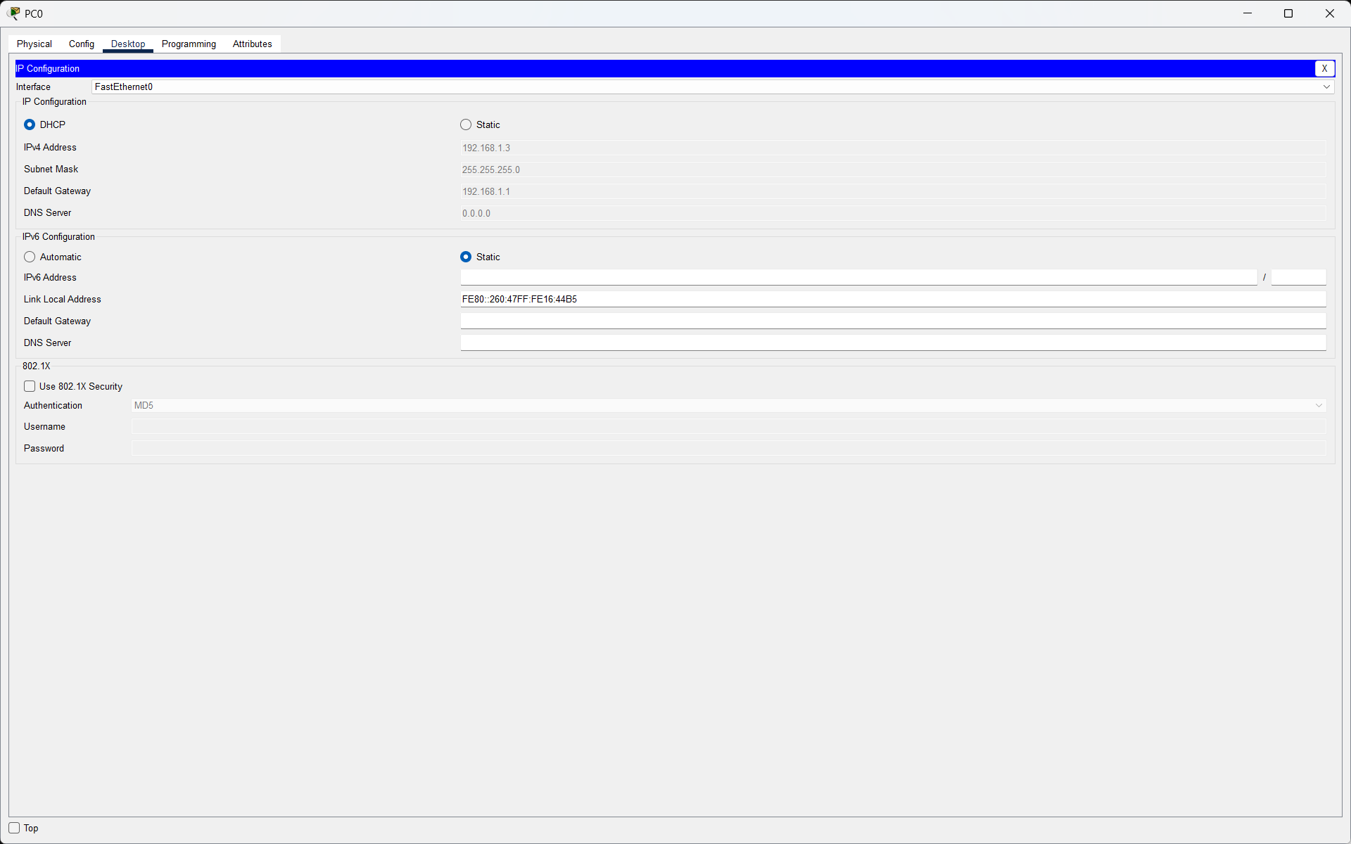
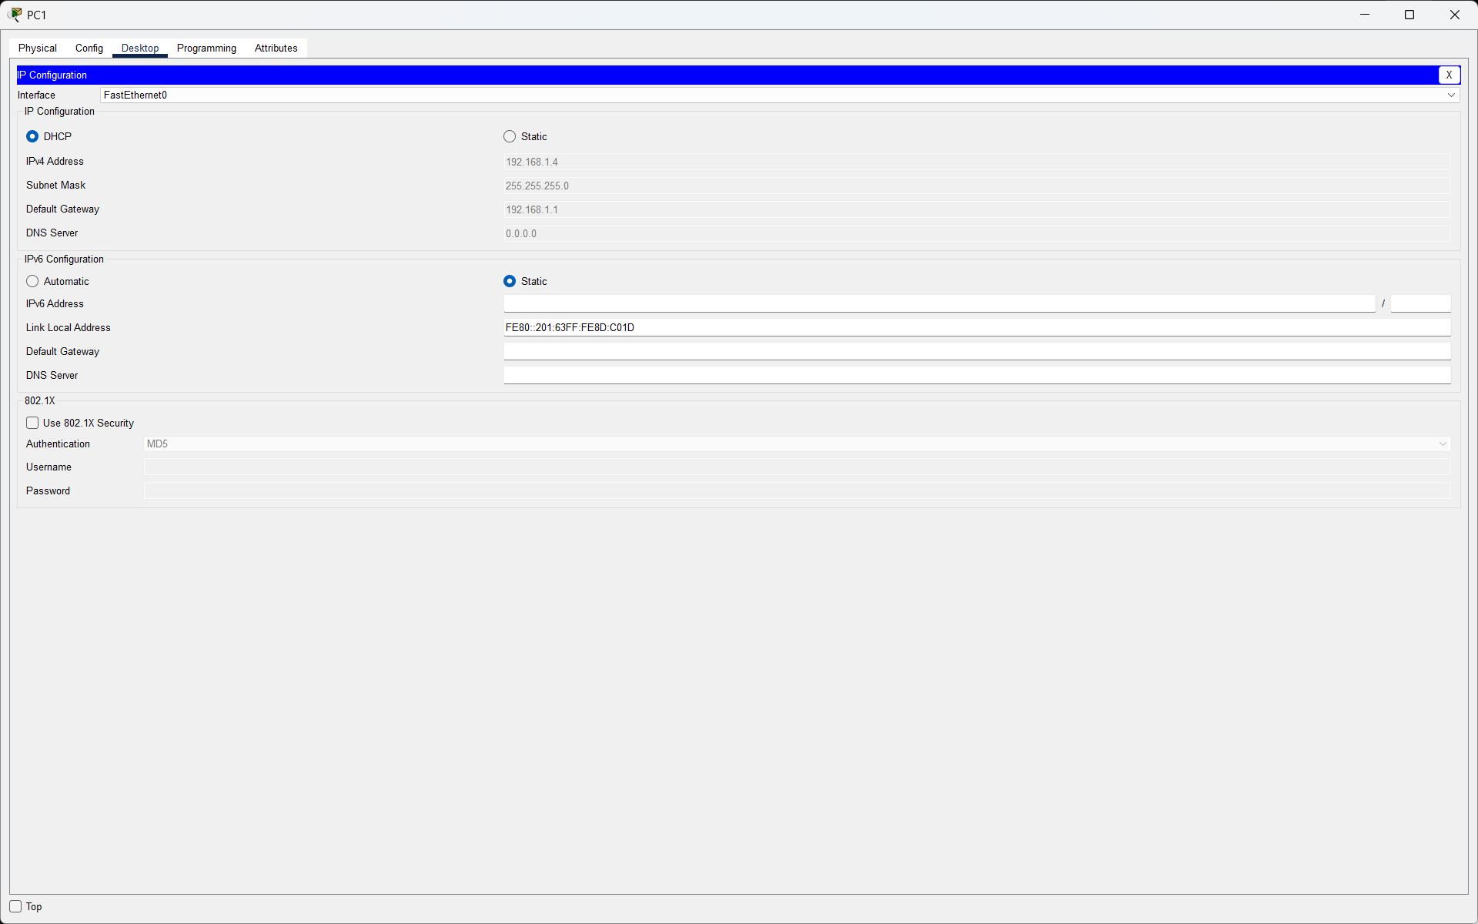
Q2. Draw a sequence diagram (hand-drawn or digital) that clearly shows each step of the DHCP process: Discover, Offer, Request, and Acknowledge, labeling the sender and receiver at each stage. Hint: Use arrows to show the direction of each message between client and server?

Answer:
The DHCP process is commonly called DORA: Discover, Offer, Request, and Acknowledge. It allows a client to automatically obtain IP configuration from a DHCP server.
Step | Sender -> Receiver | Description
1. Discover | Client -> DHCP Server | The client broadcasts a message to find an available DHCP server.
2. Offer | DHCP Server -> Client | The server offers an available IP address and network settings.
3. Request | Client -> DHCP Server | The client requests the offered IP address.
4. Acknowledge | DHCP Server -> Client | The server confirms the lease and sends the final configuration.

- Result:
The DORA sequence shows how a client and DHCP server communicate before the client starts using its assigned IP address.
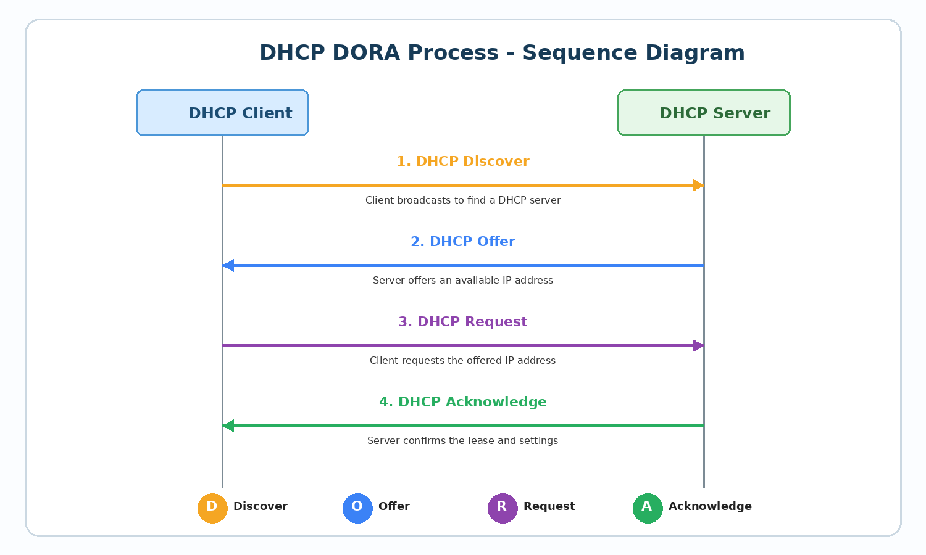

Q3. Change the DHCP pool range on your Cisco Packet Tracer DHCP server so that only one IP address is available. Add two PCs and observe what happens when both try to get an IP address. Take a screenshot of the result and explain in 2-3 lines why only one PC succeeds?
Answer:
I changed the DHCP pool so that only one IP address was available. Then I connected two PCs and selected DHCP on both clients.
- Configuration:
Setting | Value
- Start IP Address | 192.168.1.3
- Subnet Mask | 255.255.255.0
- Default Gateway | 192.168.1.1
- Maximum Users | 1

- Observation:
Device | Result
- PC0 | Received 192.168.1.3 successfully
- PC1 | DHCP failed and an PC1 Didn’t get ip

- Explanation (2-3 lines):
Only one PC succeeds because the DHCP pool contains only one available IP address. After PC0 receives that address, no free DHCP address remains for PC1, so PC1 cannot obtain a lease and falls back to an APIPA address.
- Result:
The test confirmed that the number of DHCP clients that can receive addresses depends on the number of free IP addresses available in the DHCP pool.

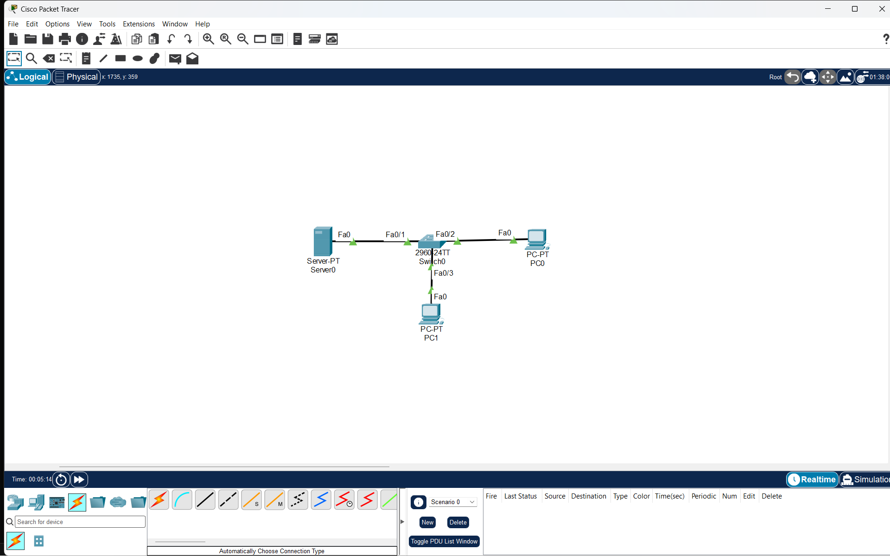
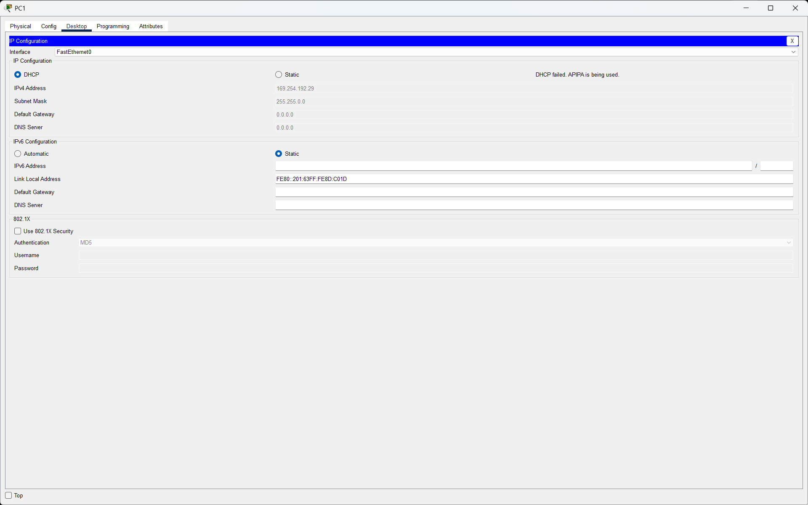
Q4. Simulate a Zomato-style restaurant WiFi scenario in Cisco Packet Tracer: configure a DHCP server to provide IP addresses to both a laptop and a smartphone (use a generic PC as smartphone). Show the assigned IPs and explain why DHCP is useful in this situation?

Answer
I simulated a restaurant WiFi network in Cisco Packet Tracer. A DHCP server was connected to a wireless router/access point, and a laptop and a generic PC labeled as a smartphone were connected as customer devices.
- Steps Performed:
1. Added a DHCP server, a wireless router/access point, one laptop, and one generic PC to represent a smartphone.
2. Configured the DHCP server with a pool named RESTAURANT_WIFI.
3. Set the default gateway to 192.168.20.1, subnet mask to 255.255.255.0, and start IP address to 192.168.20.100.
4. Enabled DHCP on both client devices.
5. Verified that the laptop and smartphone received different IP addresses automatically.
- Assigned IP Addresses:
Device | Assigned IP
- Laptop0 | 192.168.20.100
- Smartphone (Generic PC) | 192.168.20.101

- Why DHCP is useful:
DHCP is useful in a restaurant because customers can join the WiFi network without manually entering IP settings. It automatically gives each device a valid IP address, subnet mask, gateway, and other network information, making the connection fast and easy.
- Result:
Both customer devices received IP addresses automatically and were ready to communicate on the restaurant network.
